


Computer Engineering Department
Government College of Engineering & Research Avasari Khurd Savitribai Phule Pune University

Final Year of Computer Engineering 2025-26 Semester I

Project Synopsis
- Project Group ID :
- Title of the Project : AI Chatbot for Legal Advice Based on Indian Laws
- Project Guide : Prof. K.B.Sadafale
- Team Members :
Sr. | Roll No | Name | Email | Mobile | Sign
1. | 22121018 | Hrutik Wakale | hrutikwakale27@gmail.com | 9067200851
2. | 22121028 | Pratiksha Mesat | mesatpratiksha13@gmail.com | 9322471196
3. | 22121029 | Ashlesha Pathade | ashleshapathade3917@gmail.com | 9322943917

- Sponsorship details, if any :

Date: Name & Signature Name & Signature
Guide Project Coordinator

1



Abstract

In today's fast-paced world, access to timely and affordable legal advice remains a significant challenge, especially for individuals unfamiliar with legal procedures or unable to afford professional consultation. This project aims to develop an AI-powered chatbot designed to provide basic legal guidance based on Indian laws. The chatbot leverages Natural Language Processing (NLP) and machine learning algorithms to understand user queries in plain English (and optionally Hindi), interpret legal contexts, and offer accurate, law-abiding responses.
The system is designed to assist users in understanding various legal domains such as civil law, constitutional law, criminal law, family law, corporate law, consumer rights, property disputes, labor laws, and cyber laws. It ensures 24/7 accessibility, user privacy, and simple interaction through a conversational interface. The chatbot does not replace legal professionals but serves as a first-level support tool for legal awareness, helping users identify their rights, the applicable laws, and the possible next steps.
Keywords : Chatbot, Indian Laws, NLP, AI, OpenAI , LegalTech , Justice Accessibility

2

Background and Motivation

Background:-

India’s legal system, while comprehensive and structured, is often perceived as complex and inaccessible by the general public. Millions of people face legal challenges daily—ranging from family disputes and consumer complaints to employment issues and property conflicts—yet many remain unaware of their rights and the legal remedies available to them. Legal services in India are often overburdened, under-resourced, and out of reach for rural or economically disadvantaged populations. The existing legal aid infrastructure, though valuable, is insufficient to meet the growing demand for timely and clear legal guidance.
At the same time, advancements in Artificial Intelligence (AI), especially in Natural Language Processing (NLP), have made it possible to create intelligent systems that can understand and respond to human language. Chatbots, when combined with legal databases and smart reasoning capabilities, present a unique opportunity to assist users with basic legal queries in a conversational and accessible manner.

Motivation :-

The proliferation of AI and NLP technologies offers a unique opportunity to address this gap. AI-powered chatbots can process and understand natural language queries, access and analyze vast amounts of legal data, and provide responses in a user-friendly manner. This project is motivated by the potential to:

Democratize Legal Information.

Empower Citizens.

Reduce Information Asymmetry.

Support Legal Professionals.

Improve Access to Justice

Problem Definition and Objectives

Problem Statement : “ Development of an AI-Powered Chatbot for Providing Legal Advice Based on Indian Laws Using Natural Language Processing (NLP). ”
A large portion of the Indian population lacks access to affordable and timely legal advice due to high costs, limited legal awareness, and complex legal procedures. This leads to delays in justice and exploitation, especially in rural and underserved areas. There is a need for a simple, scalable solution to bridge this gap.
This project aims to develop an AI-powered chatbot that provides basic legal guidance based on Indian laws through natural language interaction. The chatbot will help users understand their rights and available legal remedies, promoting legal literacy and reducing the burden on legal aid systems.

Objectives
- Develop an AI-powered legal chatbot.
- Provide simplified legal guidance based on Indian laws.
- Ensure 24/7 accessibility through web/mobile platforms.
- Promote legal literacy among users.
- Support multilingual interaction (e.g., English and Hindi).
- Maintain user privacy and data security.
- Integrate a reliable Indian legal knowledge base.
- Provide clear disclaimers about legal limitations.
- Provide accurate and reliable legal information

Literature Survey

The field of legal technology (LegalTech) has seen significant growth in recent years, with AI playing an increasingly prominent role. Existing research and commercially available tools provide valuable insights for this project:

- Legal Expert Systems and Rule-Based AI
Early legal expert systems like MYCIN and Racter laid the groundwork for AI in decision support systems. In the legal domain, rule-based systems were developed to simulate human legal reasoning. Tools like Legal Expert Systems (LES) used predefined rules and logic trees, but lacked the flexibility to handle unstructured user input or natural language queries.

- Chatbots in the Legal Domain
Projects such as DoNotPay (USA) became popular for helping users fight parking tickets and understand legal procedures using a conversational AI model. It proved the potential of AI chatbots in making legal processes more accessible. However, DoNotPay is based on U.S. law and cannot be directly applied to the Indian context.

- AI and Legal Text Processing
Research in Natural Language Processing (NLP) and Legal Text Mining has enabled the extraction of relevant legal concepts and summaries from complex documents. Tools like LexisNexis and CaseMine in India use NLP for legal research but are mainly designed for lawyers and not for the general public.

- Multilingual Legal Chatbots
Studies have shown that multilingual support significantly improves the accessibility of digital legal tools in linguistically diverse countries like India. Tools like Jugalbandi (a chatbot developed under the AI4Bharat initiative) demonstrated the effectiveness of AI in providing legal and government scheme information in multiple Indian languages.

- Limitations of Existing Systems
Existing legal bots either lack Indian legal data or focus on a single legal domain. Most are also not designed for the layperson and assume basic legal knowledge. There is a lack of scalable, user-friendly, India-specific AI chatbots that provide general legal awareness and first-level legal guidance in a conversational format.

- Natural Language Processing for Legal Texts
Research in NLP has focused on adapting techniques for understanding the nuances of legal language, including legal jargon, statutory interpretation, and identification of relevant legal concepts.

- Early legal AI relied on rule-based systems
While laying the foundation, these systems (like LES) were limited in their ability to process natural language input and handle unstructured queries, showcasing a need for more advanced NLP techniques.

- Chatbots have shown potential in the legal domain but lack India-specific focus
The success of chatbots like DoNotPay demonstrates the accessibility benefits of conversational AI for legal issues; however, these are often jurisdiction-specific (like US law) and highlight the need for solutions tailored to Indian laws.

Methodology

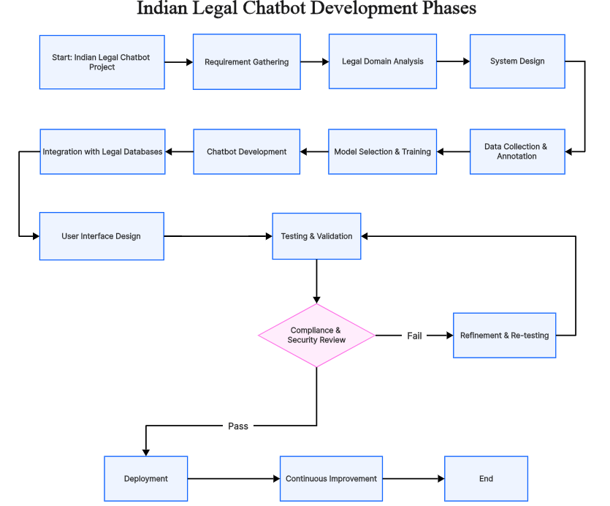

1. Start: Indian Legal Chatbot Project
This marks the initiation of the project. At this stage:
- The goal and scope are defined.
- Project stakeholders and roles are identified.
- Initial feasibility and use-case brainstorming are done.
- Project planning documents (timeline, tech stack, objectives) are drafted.
2. Requirement Gathering
In this phase:
- Functional requirements are collected (e.g., user should get advice on IPC laws).
- Non-functional requirements like response speed, security, and multilingual support are also defined.
- Inputs from legal professionals, users, and technical team are gathered through interviews, surveys, etc.
3. Legal Domain Analysis
Here, the team deeply studies:
- Indian legal frameworks, including IPC, CrPC, RTI, Labor Laws, etc.
- Types of queries users might ask (e.g., how to file an FIR).
- Identifies legal boundaries: chatbot gives basic advice, not full legal consultation.
4. System Design
In this stage:
- System architecture is designed (frontend–backend–AI pipeline).
- Selection of tech stack (e.g., React, Node.js, MongoDB, Gemini API).
- Database schema for storing laws, FAQs, and chat history is planned.
- Security, API flow, and scalability are considered.
5. Data Collection & Annotation
This is the legal knowledge base preparation phase:
- Legal data is collected from Indian government sources and legal websites.
- FAQs, common case examples, and sections are extracted.
- If using supervised learning, questions are annotated with intent and entities (like "Section 498A").

6. Model Selection & Training
AI/NLP core is built in this stage:
- Choose between pre-trained models (like GPT or BERT) or build custom.
- Models are fine-tuned on legal datasets for Indian laws.
- Training data includes legal questions, law sections, and expected replies.
- Evaluate using accuracy, F1-score, or BLEU score for NLP.
7. Chatbot Development
Now the chatbot framework is built:
- The chatbot is coded using frameworks like Rasa, Dialogflow, or a custom Node.js+OpenAI/Gemini stack.
- Logic includes context retention, fallback answers, FAQ routing, etc.
- Response templates and fallback mechanisms are implemented.
8. Integration with Legal Databases
The chatbot is now connected to actual legal content:
- Link MongoDB/SQL database of laws to chatbot.
- Use APIs like IndiaCode or LawRato if applicable.
- Build internal API endpoints to query law by section number or keyword.
9. User Interface Design
User-facing interface is developed:
- Designed with React (or mobile-friendly frameworks).
- Chat interface includes type and voice input.
- Features include multi-language support, dark mode, and search history.
- Designed for accessibility and ease of legal understanding.

10. Testing & Validation
Full system testing is done:
- Unit Testing of individual components.
- Integration Testing of chatbot with backend, API, and UI.
- Legal Validation: Sample questions are checked with legal experts for correctness.
- Ensure the chatbot does not misguide the user.
11. Compliance & Security Review
Here the project is reviewed for:
- Compliance: Ensures it doesn’t impersonate a lawyer or misrepresent the law.
- Security: Protects user queries and data using encryption, secure endpoints, etc.
- Pass leads to deployment, fail returns to refinement.
12. Refinement & Re-testing
If the chatbot fails the review:
- Feedback is analyzed.
- Fixes made to incorrect responses, security holes, or UI bugs.
- Re-tested in the Testing & Validation phase.
13. Deployment
Once passed:
- The chatbot is hosted using services like Render, Railway (for backend) and Netlify or Vercel (for frontend).
- CI/CD setup ensures automatic deployment on future updates.
- App is made live for users on web or mobile platforms.
15. End
- Final documentation, code handover, and report writing are done.
- Ready for academic/project evaluation or handoff to maintenance team.

Architecture Survey

A potential high-level system architecture for the AI Legal Chatbot could include the following components:
- User Interface (UI): A web or mobile application allowing users to input their legal queries in natural language.
- NLP Engine: Responsible for processing the user's input, understanding the intent, and extracting relevant keywords and legal concepts. This could involve using libraries like NLTK, spaCy, or leveraging pre-trained models from platforms like Hugging Face.
- Dialogue Manager: Manages the conversation flow, maintains context, and determines the appropriate response based on the user's input and the information retrieved.
- Knowledge Base: A repository of structured and unstructured legal data, including:
- Text of Indian laws (Acts, Rules, Regulations).
- Summaries and interpretations of legal concepts.
- Relevant case law and precedents.
- Frequently Asked Questions (FAQs) on legal topics.
- Information Retrieval Module: Responsible for searching the knowledge base and retrieving relevant documents or information based on the processed user query. This could involve techniques like keyword search, semantic search, or vector embeddings.
- Response Generation Module: Formats the retrieved information into a concise and understandable response for the user. This might involve using the LLM to synthesize information from multiple sources.
- API Layer: Enables communication between different modules and potential integration with other systems.
- User Management (Optional): For features like saving chat history or personalized advice in future iterations.

List of Modules and Functionalities

The AI Legal Chatbot could offer the following modules and functionalities:
- Legal Query Answering: Allows users to ask legal questions in natural language and receive relevant information and explanations.
- Legal Concept Explanation: Provides definitions and explanations of legal terms and concepts.
- Basic Legal Procedure Guidance: Offers general guidance on legal processes for common legal issues (e.g., filing a complaint, understanding court procedures).
- Relevant Law Identification: Identifies and presents the specific sections of Indian law relevant to the user's query.
- Case Law Snippet Retrieval: In more advanced versions, it could retrieve relevant snippets from landmark case judgments.
- Multi-lingual Support (Future): Option to interact with the chatbot in different Indian languages.
- Document Understanding (Future): Ability to analyze user-uploaded documents and provide relevant legal insights.
- Disclaimer: Clearly state that the chatbot provides informational purposes only and does not constitute legal advice from a qualified lawyer. Users should be advised to consult with legal professionals for specific legal matters.
Future Goals

The project can evolve in several ways, including:
- Integration:
Integrate additional data sources and improve model accuracy and efficiency.
- CyberSecurity :
On Completion of this Project we will add Cybersecurity to this Project to protect it from the hackers.
- Expand Legal Coverage:
Include more legal domains such as taxation, environmental law, intellectual property, and corporate law.
- Multilingual Support:
Extend support to major Indian regional languages like Tamil, Telugu, Bengali, Marathi, etc., to improve accessibility.
- Collaboration with Legal Institutions:
Partner with NGOs, legal aid clinics, and law schools to validate and enrich the chatbot’s knowledge base.

Keywords: Artificial Intelligence(AI), Legal Chatbot, Indian Laws, Natural Language Processing(NLP), Ethical AI.

Software and Hardware Requirements

The specific requirements will depend on the complexity and scale of the project, but typical requirements might include:

Software:
- Operating System: Linux, Windows, or macOS for development.
- Programming Language: JavaScript (for NLP).
- Database: For storing the knowledge base (e.g., PostgreSQL, MongoDB) and potentially user data.
- Web Framework (for UI): React, Vite And TailwindCSS.
- Cloud Platform (for deployment): AWS, Google Cloud, Azure (depending on scalability needs).

Hardware:
- Development Machine: A computer with sufficient processing power (CPU/GPU), RAM, and storage.
- Server Infrastructure (for deployment): Servers or cloud-based virtual machines with adequate resources to handle user traffic and processing demands. The requirements will scale with the number of users and the complexity of the AI models.

References

Research Papers and Articles
[1] R. Barzilay and A. McCallum, “Open-Domain Question Answering Based on Information Retrieval,” in Proceedings of the 2006 Conference on Empirical Methods in Natural Language Processing (EMNLP), 2006. [Online]. Available: https://aclanthology.org/W06-1615.pdf
[2] M. Lippi and P. Torroni, “Argumentation Mining: State of the Art and Emerging Trends,” Artificial Intelligence and Law, vol. 24, pp. 243–290, 2016, doi: 10.1007/s10506-016-9181-6.
[3] J. Savelka, K. D. Ashley, and M. Grabmair, “Mining Information from Statutory Texts,” 2015. [Online]. Available: https://arxiv.org/abs/1505.03753

Datasets & Legal APIs
[1] Government of India, “India Code Portal – Repository of Indian Laws,”
[Online].[Accessed: Jul. 31, 2025].
[2] VakilSearch, “Legal Services and FAQs,” [Online]. [Accessed: Jul. 31, 2025].
[3] LawRato, “Free Legal Advice from Top Rated Lawyers in India,” [Online].
[Accessed: Jul. 31, 2025].

